**DBMS LAB 3**

**PROGRAM 3: SUPPLIER DATABASE**

Consider the following schema:

SUPPLIERS (sid#: int, sname: string, address: string)

PARTS (pid#: int, pname: string, color: string)

CATALOG (sid: int, pid: int, cost:real)

**create table suppliers**

**(**

**sid integer primary key,**

**sname varchar(20),**

**address varchar(50)**

**);**

**create table parts**

**(**

**pid integer primary key,**

**pname varchar(20),**

**color varchar(10)**

**);**

**create table catalog**

**(**

**sid integer,**

**pid integer,**

**cost real,**

**primary key(sid,pid),**

**foreign key(sid) references suppliers(sid) on delete cascade on update cascade,**

**foreign key(pid) references parts(pid) on delete cascade on update cascade**

**);**

**insert into suppliers(sid,sname,address) VALUES**

**(001,'Rohan','Mangalore'),**

**(002,'Avni','Bangalore'),**

**(003,'Pratibha','Bagalkot'),**

**(004,'Rahul','Udupi'),**

**(005,'Prithvi','Hassan');**

**insert into parts(pid,pname,color) VALUES**

**(001,'Pipe','white'),**

**(002,'Screw','red'),**

**(003,'Nail','black'),**

**(004,'Tap','grey'),**

**(005,'bottle','red'),**

**(006,'plywood','brown');**

**insert into catalog(sid,pid,cost) VALUES**

**(001,001,50.00),**

**(001,006,120.00),**

**(002,002,75),**

**(002,005,100),**

**(003,002,45),**

**(003,003,75),**

**(004,001,140),**

**(004,002,38),**

**(004,003,42),**

**(004,004,310),**

**(004,005,79),**

**(004,006,110),**

**(005,002,50),**

**(005,003,48);**

**select * from suppliers;**

**select * from parts;**

**select * from catalog;**

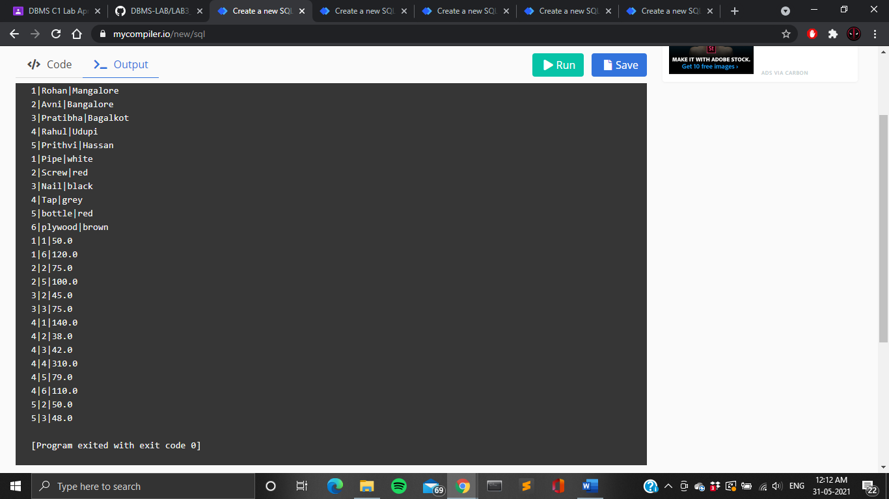





The catalog relation lists the prices charged for parts by suppliers. Write the following queries in SQL:

1. Find the pnames of parts for which there is some supplier.

**select distinct parts.pname from parts,catalog where parts.pid = catalog.pid;**

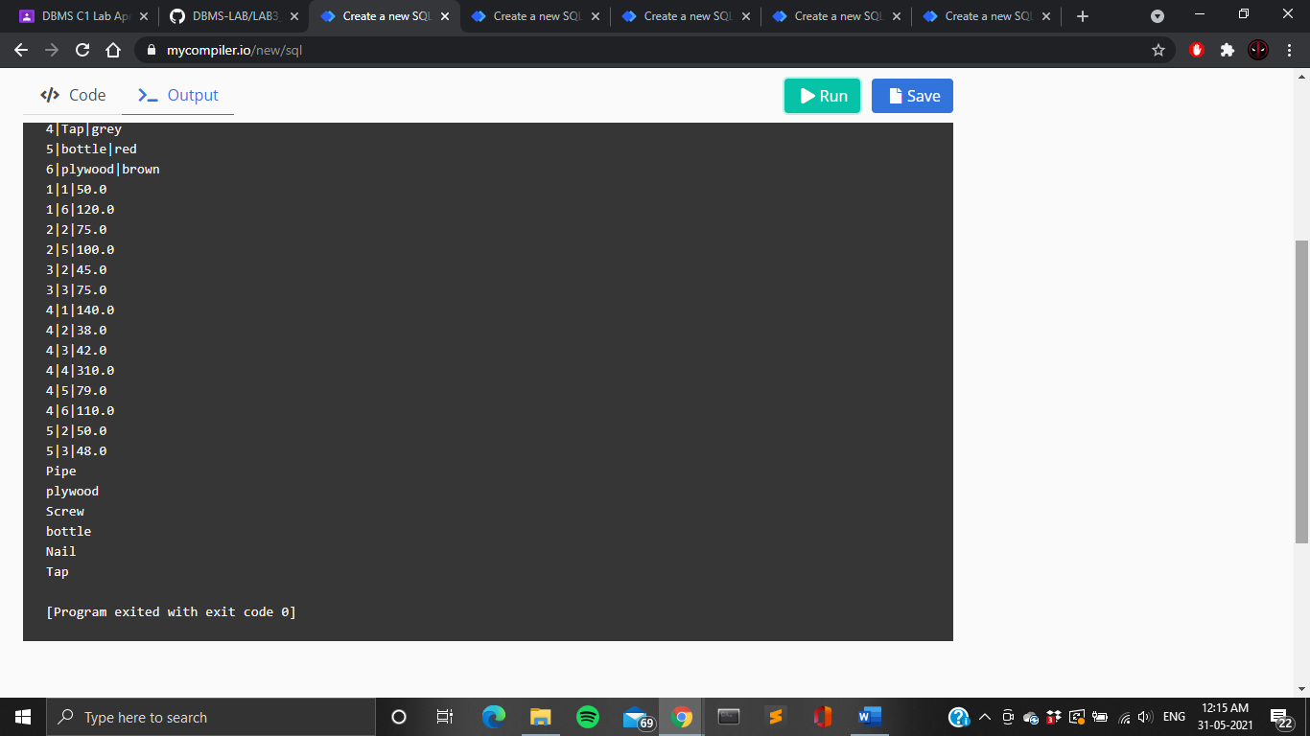

1. Find the snames of suppliers who supply every part.

**select sname from suppliers s,catalog c where s.sid=c.sid group by s.sid,sname having count(pid)=6;**

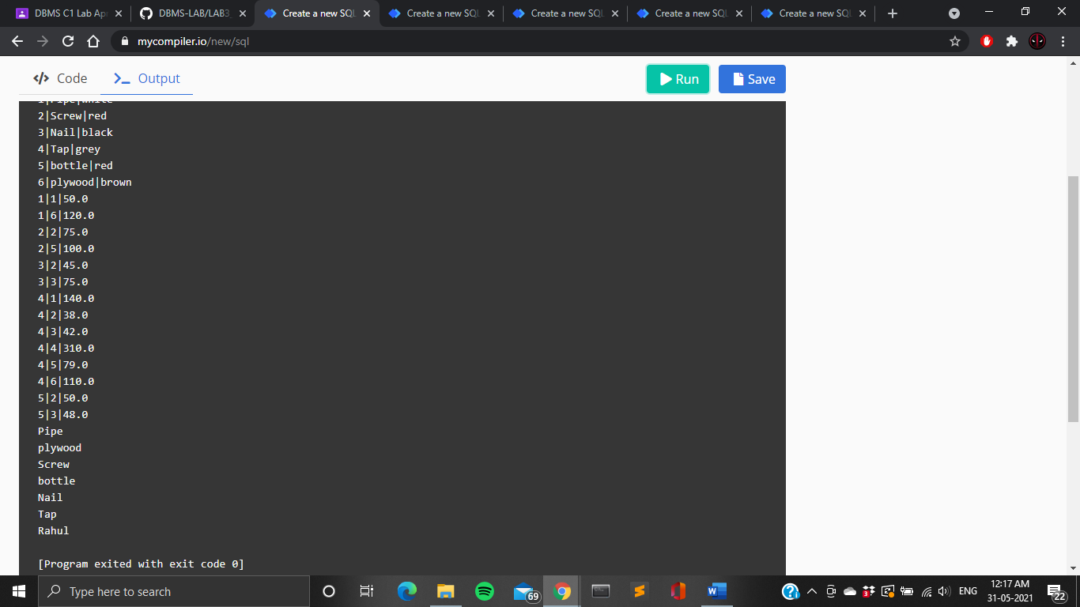

1. Find the snames of suppliers who supply every red part.

**select s.sname from suppliers s where s.sid in (select c.sid from catalog c,parts p where c.pid=p.pid and p.color='red' group by c.sid having count(c.pid)=(select count(*) from parts p where p.color='red'));**

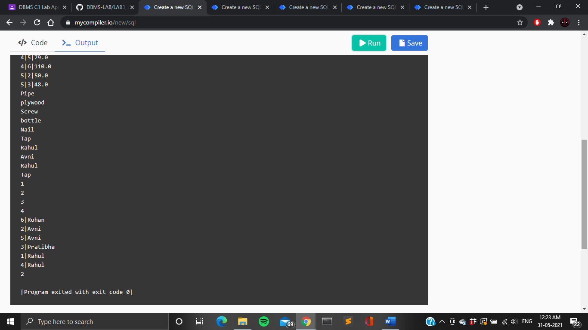

1. Find the pnames of parts supplied by Rahul and no one else.

**SELECT P.pname FROM Parts P, Catalog C, Suppliers S WHERE P.pid = C.pid AND C.sid = S.sid AND S.sname = "Rahul" AND NOT EXISTS ( SELECT * FROM Catalog C1, Suppliers S1 WHERE P.pid = C1.pid AND C1.sid = S1.sid AND S1.sname <>"Rahul" );**



1. Find the sids of suppliers who charge more for some part than the average cost of that part (averaged over all the suppliers who supply that part).

**SELECT DISTINCT C.sid FROM Catalog C WHERE C.cost > ( SELECT AVG (C1.cost) FROM Catalog C1 WHERE C1.pid = C.pid );**



1. For each part, find the sname of the supplier who charges the most for that part.

**SELECT P.pid, S.sname FROM Parts P, Suppliers S, Catalog C WHERE C.pid = P.pid AND C.sid = S.sid AND C.cost = (SELECT MAX(C1.cost) FROM Catalog C1 WHERE C1.pid = P.pid);**



1. Find the sid of suppliers who supply only red parts.

**select s.sid from suppliers s where s.sid in(select c.sid**

**from catalog c where c.sid not in (select distinct(ca.sid)**

**from catalog ca,parts p where ca.pid=p.pid and p.color!='red'));**

